Business Rule Nested Solution

Examples 1
Hide/unhide nested rule example 2
Enable/disabled nested rule example 2
How to apply to others investigation pages? 3
Actual behavior 3
Solution 4
Code 5
Improvements 6
Generic business rules (NBS 6.0) 8
Code updates 8
addNestedFunctions 8
getNestedFunction 10
getWaRuleMetadataDTFromPageRuleCollection 11
Examples 12
Hide/Unhide 12
Enable/Disable 14

Examples

The business rule nested solution on an edit page contemplates the hide/unhide events as well as the enable/disable events. We are going to show some examples for being able to test the results on localhost:
URL: http://10.62.15.120:7001/nbs/login

Hide/unhide nested rule example

An example of how this works is the Hepatitis C Acute Investigation. This investigation page contains tattoo questions. Open a Hepatitis C Acute page and edit the investigation. Go to the Hepatitis Extended tab. For the question “Did the patient receive a tattoo?” select ‘Yes’, for the question “Where was the tattoo performed?” select ‘Other’.


Then, for the question “Did the patient receive a tattoo?” select “No”. You will see that the two questions related to the tattoo are hidden.
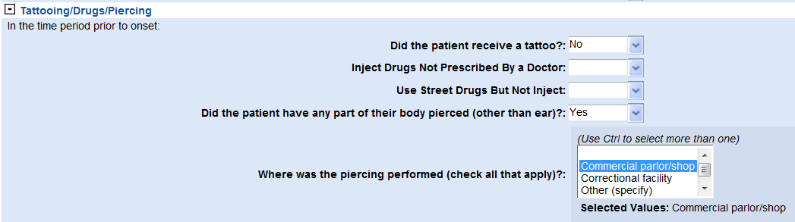

Enable/disabled nested rule example

An example of how this works is the Chancroid Investigation. This investigation page contains drug questions. Open a Chancroid page and edit the investigation. Go to the Core Info tab. For the question “No drug use reported” select ‘No, for the question “Other drugs used” select ‘Yes.

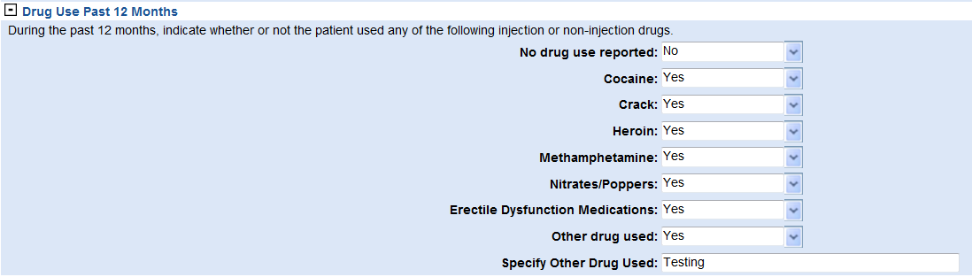

Then, for the question “No drug use reported” select “Did not ask”. You will see that the two questions related to the drug are disabled.
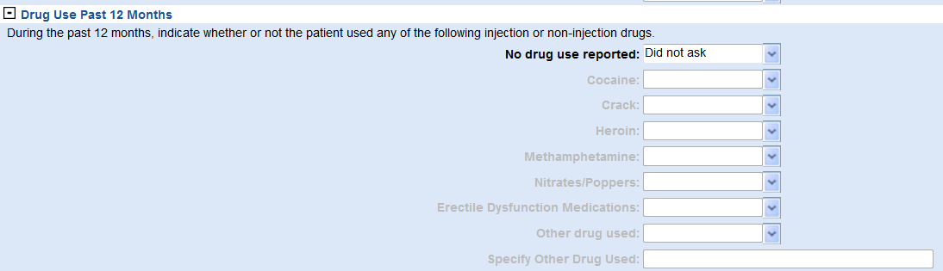

How to apply to others investigation pages?

To see this change working on different investigation pages, just go to System Management > Manage Pages and republish the page.

Actual behavior

The actual behavior for the business rule is the following: select “Yes” at the question “Did the patient receive a tattoo?” Then, select “Other” at “Where was the tattooing performed (Check all that apply)?”


Then change the first question to “No”. You can see that the Other Location(s) Tattoo received” is still showing.
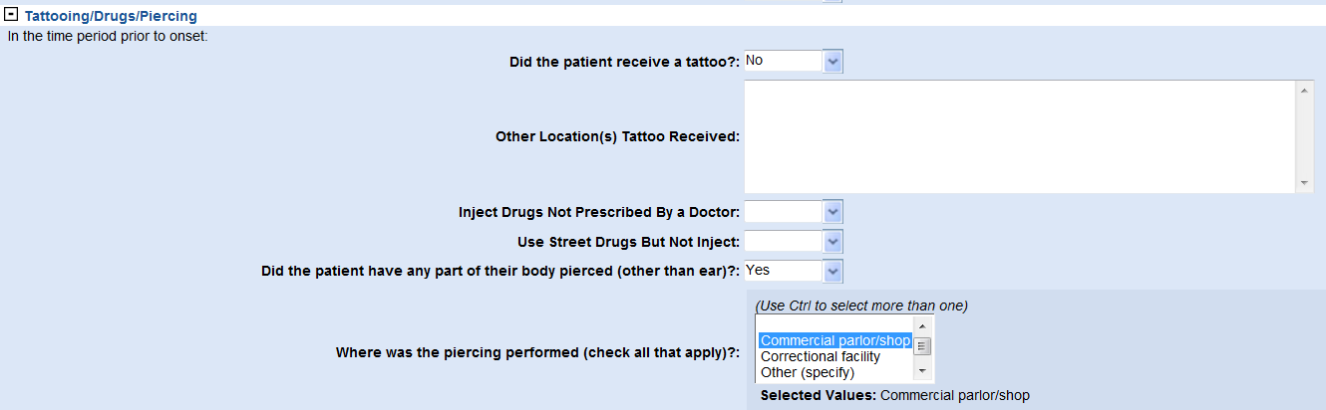

Solution

- File modified: MarshallPageRules.java
- New functionality: new functionality has been created to add to the onchange (hide/unhide and enable/disabled) event of an element the function associated to the nested element.
- Where to use the function: for the hide/unhide behavior, we need to add the new functionality into the addHideOrShowRule and for the enable/disable behavior, we need to add the new functionality into the addEnableDisableRule.
- Behavior: tattoo example (hidden/unhidden) or drugs (enable/disable) both have the same behavior, now they work as they are supposed to, when we select “No” in the parent element (or “Yes”, depending on the meaning of the question), all the associated elements are hidden/disabled.

Code

- AddNestedFunctions function:

//Fatima function: for now, just one level
public void addNestedFunctions(WaRuleMetadataDT ruleMeta, PageElementType element, HashMap<String, PageElementType> quesMap, Collection <Object> pageRuleCollection){

String nestedRuleID = ruleMeta.getTargetQuestionIdentifierString();

if(nestedRuleID.contains(",")){
List<String> items = Arrays.asList(nestedRuleID.split("\\s*,\\s*"));

for(int i=0; i<items.size(); i++)
getNestedFunction(items.get(i), element,pageRuleCollection);//For more than one nested rule
}else
getNestedFunction(nestedRuleID, element,pageRuleCollection);

}

- GetNestedFunction function:

public void getNestedFunction(String nestedRuleID, PageElementType element, Collection <Object> pageRuleCollection){

String funcNested=getNestedRule(nestedRuleID, pageRuleCollection);

if(!funcNested.equals("")){//add the function nested

String curOnChange = element.getCodedQuestion().getOnChange();
if(!curOnChange.contains(funcNested))//avoid repeats
element.getCodedQuestion().setOnChange(curOnChange + ";" + funcNested);
}

}

- GetNestedRule function:

public String getNestedRule(String nestedRuleID, Collection <Object> pageRuleCollection){
//pageRuleCollection.toArray()("WaRuleMetadataDT")
pageRuleCollection.toArray();
String nameFunction="";
Object[] listRules = pageRuleCollection.toArray();
for(int i=0; i<listRules.length; i++){
WaRuleMetadataDT rule2 = (WaRuleMetadataDT)listRules[i];
if(rule2.getSourceQuestionIdentifierString().equals(nestedRuleID))

if(nameFunction=="")
nameFunction = rule2.getJavascriptFunctionNm();
else//added in case the same rule has more than one function (More than one object in pageRuleCollection)
nameFunction = nameFunction + ";" + rule2.getJavascriptFunctionNm();

}

return nameFunction;
}

Improvements

This solution still needs to be improved for covering the following cases:

- This solution is just for three levels like A -> B -> C, but, if there’s another case with more levels like A->B->C->D->etc, it is not covered. I don’t know if we have this case in our pages now, but it should be fine to be prepared for that. We need to know if we really need to cover this.

ND-1826: EnableOrDisableOther

Resolution

Issue 1
File: MarshallPageRules.java
Method: getNestedFunction() This method was created as part of the solution for nested business rules
Code: at the end of this method, add the following code:
//Add static rules for Oth questions
PageElementType pageElement = quesMap.get(nestedRuleID);
if(pageElement!=null){
CodedQuestionType codedQues = pageElement.getCodedQuestion();
if(codedQues!=null){
String onchange = codedQues.getOnChange();
if(onchange!=null && onchange.contains("enableOrDisableOther"))
{ element.getCodedQuestion().setOnChange(element.getCodedQuestion().getOnChange()+";"+onchange); }
}
}
Also, the method definition has been changed from:
public void getNestedFunction(String nestedRuleID, PageElementType element, Collection <Object> pageRuleCollection)
to:
public void getNestedFunction(String nestedRuleID, PageElementType element, Collection <Object> pageRuleCollection, HashMap<String, PageElementType> quesMap)

Issue 2
When the parent of an oth is hidden, the child should be hidden too. For getting this approach, the resolution is the following:
File: PageSpecific.js
Method: enableOrDisableOther
Code: add at the end of the method the following code:
//if the parent is hidden, hide the oth child. The attribute display has not been used since the element doesn't have that attribute. The <tr> has the attribute disable.
if(getElementByIdOrByName(fromSelFieldId).offsetWidth == 0 && getElementByIdOrByName(fromSelFieldId).offsetHeight == 0)
pgHideElement(toTextField);
else
pgUnhideElement(toTextField);

Generic business rules (NBS 6.0)

As part of NBS 6.0, it was decided to improve the existing code and make it generic, that way we can create more than 2 level business rules. In order to do that, recursive calls have been added to the existing code:

Code updates

addNestedFunctions

The method addNestedFunctions is called recursively while the question has a target question associated to it. At the end, each of the methods in the onchange and the actual business rule is added to the onchange of the parent. The green code has been added:
public void addNestedFunctions(WaRuleMetadataDT ruleMeta, PageElementType element, HashMap<String, PageElementType> quesMap, Collection <Object> pageRuleCollection){

String nestedRuleID = ruleMeta.getTargetQuestionIdentifierString();

if(nestedRuleID.contains(",")){
List<String> items = Arrays.asList(nestedRuleID.split("\\s*,\\s*"));

for(int i=0; i<items.size(); i++){
//Recursive
PageElementType element2 = null;
String questionIdentifier = items.get(i);
element2 = quesMap.get(questionIdentifier);
WaRuleMetadataDT ruleMeta2= getWaRuleMetadataDTFromPageRuleCollection(questionIdentifier,pageRuleCollection);
if(ruleMeta2!=null)
addNestedFunctions(ruleMeta2, element2, quesMap, pageRuleCollection);
//End recursive

getNestedFunction(items.get(i), element,element2,pageRuleCollection, quesMap);//For more than one nested rule

}
}else{

PageElementType element2 = null;
String questionIdentifier = nestedRuleID;
element2 = quesMap.get(questionIdentifier);
WaRuleMetadataDT ruleMeta2= getWaRuleMetadataDTFromPageRuleCollection(questionIdentifier,pageRuleCollection);
if(ruleMeta2!=null)
addNestedFunctions(ruleMeta2, element2, quesMap, pageRuleCollection);

getNestedFunction(nestedRuleID, element,element2,pageRuleCollection, quesMap);

}

}

getNestedFunction

Some changes done to this method consist of getting the onchange of the child question and add it to the onchange of the parent. For doing that, the child element has been added as a parameter to the method.

public void getNestedFunction(String nestedRuleID, PageElementType element,PageElementType element2, Collection <Object> pageRuleCollection, HashMap<String, PageElementType> quesMap){

String funcNested=getNestedRule(nestedRuleID, pageRuleCollection);

if(!funcNested.equals("")){//add the function nested

String curOnChange = element.getCodedQuestion().getOnChange();
String previousOnChange = "";

if(element2.getCodedQuestion()!=null)
previousOnChange=element2.getCodedQuestion().getOnChange();

if(curOnChange==null)
curOnChange="";
if(previousOnChange==null)
previousOnChange="";

if(!curOnChange.contains(funcNested))//avoid repeats
element.getCodedQuestion().setOnChange(curOnChange + ";" + funcNested);
if(!curOnChange.contains(previousOnChange)){//avoid repeats
curOnChange = element.getCodedQuestion().getOnChange();
element.getCodedQuestion().setOnChange(curOnChange+";"+ previousOnChange);
}

}

getWaRuleMetadataDTFromPageRuleCollection

Also this new method has been added. It affects the performance, so once this is tested and working fine, it could be improved by creating a hashmap<string, object>, being the string the question_identifier and the object the WaRuleMetadataDT. My only concern is in case the same question identifier has more than 1 WaRuleMetadataDT associated to it. This should have been an issue in 2 level business rules, since a similar method is used for that: getNestedRule.
/**
* getWaRuleMetadataDTFromPageRuleCollection: returns the WaRuleMetadataDT associated to the questionIdentifier received as a parameter
* @param questionId
* @param pageRuleCollection
* @return
*/
public WaRuleMetadataDT getWaRuleMetadataDTFromPageRuleCollection(String questionId, Collection <Object> pageRuleCollection){
pageRuleCollection.toArray();
WaRuleMetadataDT waRuleMetadataToReturn = null;

Object[] listRules = pageRuleCollection.toArray();
for(int i=0; i<listRules.length; i++){
WaRuleMetadataDT rule2 = (WaRuleMetadataDT)listRules[i];
if(rule2.getSourceQuestionIdentifierString().equals(questionId))
waRuleMetadataToReturn = rule2;
}
return waRuleMetadataToReturn;
}

Examples

Hide/Unhide

Example of Hide/Unhide business rules:

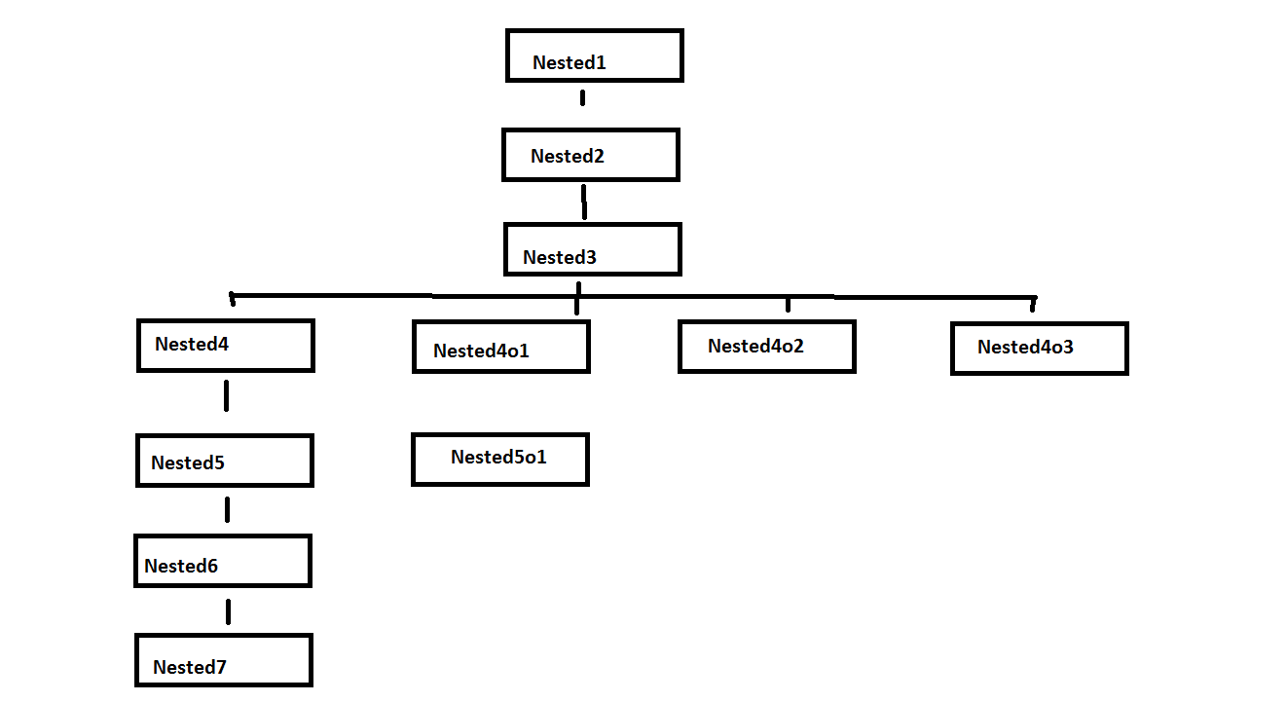

Selecting all the first options of each question will show the next business rule
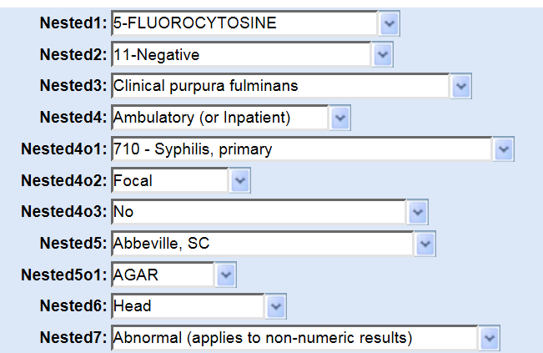
Selecting the second option in Nested1 will hide the rest of the questions:
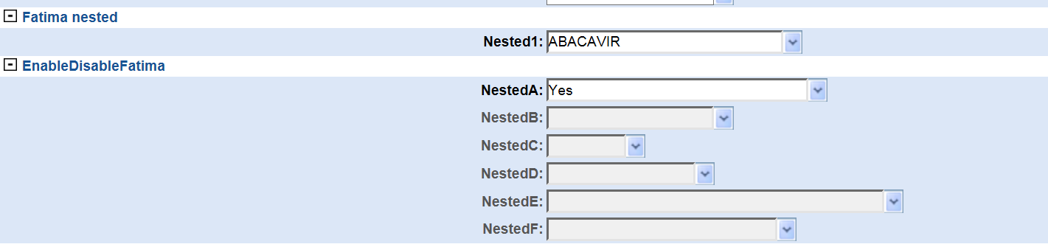
Or if Nested 4 is changed to the second option, Nested 5, Nested 6 and Nested 7 will be hidden:
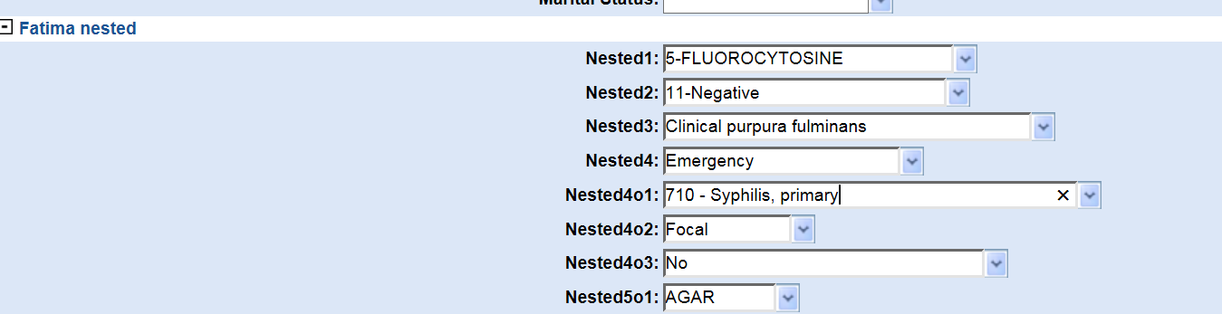

Enable/Disable

Example of Enable/Disable business rules:

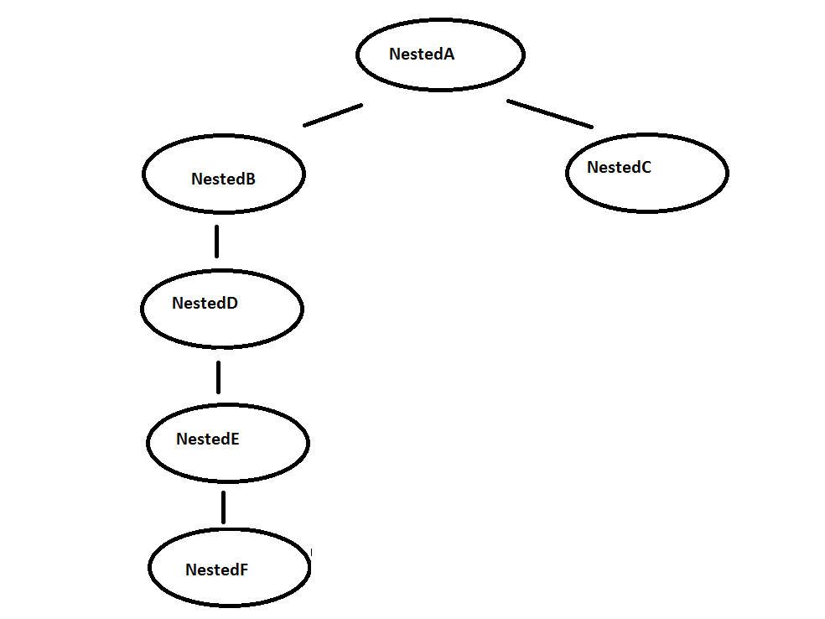
Selecting all the first options of each question will show the next business rule:

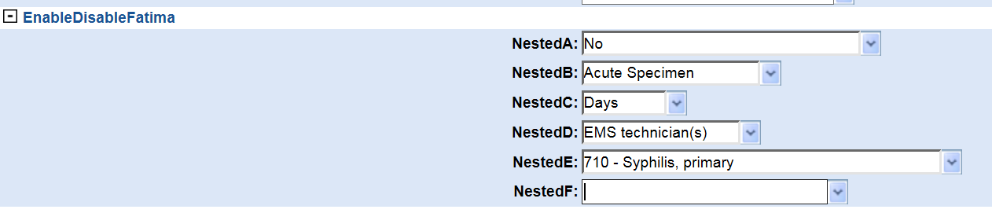

If nested A changes to the second option, the rest of questions will be disabled:

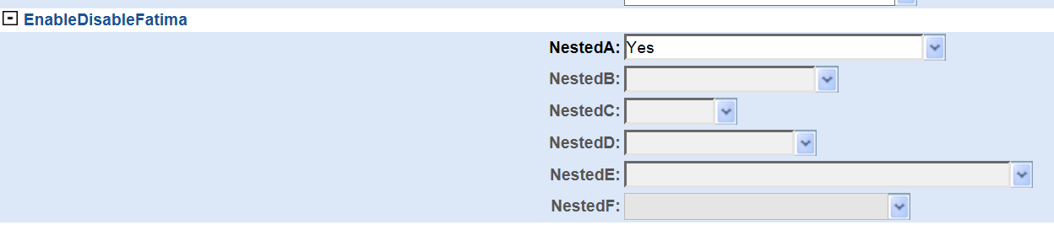
Or if Nested B changes to the second option, Nested D, Nested E and Nested F will be disabled:

